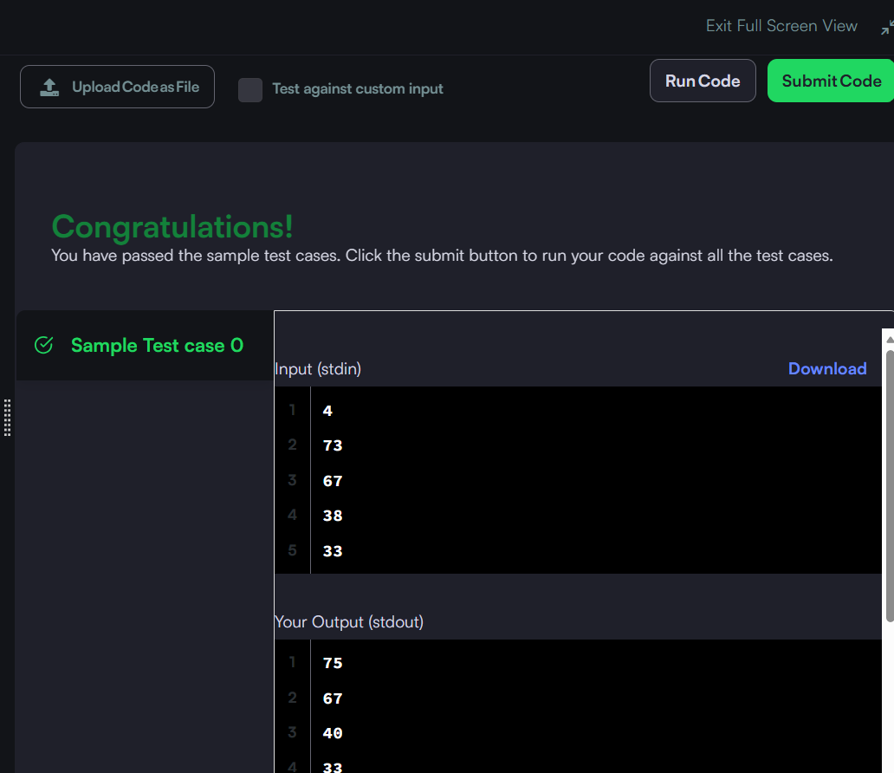

Hacker rank : Grading Students | HackerRank
Code:
#include <stdio.h>
#include <stdlib.h>

// Complete the gradingStudents function below.
// The function returns an array of integers allocated dynamically.
int* gradingStudents(int grades_count, int* grades, int* result_count) {
*result_count = grades_count;
int* rounded_grades = malloc(grades_count * sizeof(int));

for (int i = 0; i < grades_count; i++) {
int grade = grades[i];

// If grade is less than 38, no rounding occurs (failing grade)
if (grade < 38) {
rounded_grades[i] = grade;
} else {
// Find the next multiple of 5
int next_multiple = (grade + 4) / 5 * 5;

// If the difference between the grade and the next multiple of 5 is less than 3
if (next_multiple - grade < 3) {
rounded_grades[i] = next_multiple;
} else {
rounded_grades[i] = grade;
}
}
}

return rounded_grades;
}

int main() {
int n;
if (scanf("%d", &n) != 1) return 0;

int* grades = malloc(n * sizeof(int));
for (int i = 0; i < n; i++) {
scanf("%d", &grades[i]);
}

int result_count;
int* result = gradingStudents(n, grades, &result_count);

for (int i = 0; i < result_count; i++) {
printf("%d\n", result[i]);
}

free(grades);
free(result);

return 0;
}

